Name _________________________________
Date ______________________ Pd ________

Eisenhower, McCarthyism, and the Cold War

I. The Early Years of the Cold War: 1945-1949
A. During the Cold War, the USA & USSR were rival _______________________________ who competed to spread their ideology
B. From 1945 to 1949, President Truman used _____________________ to successfully stop the spread of communism in Europe
1. Truman Doctrine, ________________________________, NATO, and Berlin Airlift
2. When communism spread to _________________ in 1949, the USA feared the “__________________________________” & became more aggressive in its efforts to stop communism (_____________________________________)
II. The Cold War Escalates: 1949-1960
A. From 1949 to 1960, the Cold War escalated as a result of a nuclear arms race, space race, & espionage
1. Arms Race
a. The U.S. _________________ on nuclear weapons ended in 1949 when the USSR successfully _____________________ an atomic bomb
b. The Soviet development of the atomic bomb led to a nuclear __________________________ between the USA & USSR
c. In 1952, the USA tested the first ____________________________________________ which is _______________ times more powerful than the atomic bomb
d. The Soviet Union _________________________________________________________ its own hydrogen bomb in 1953
e. By 1959, both the USA & USSR developed _______________________________ called intercontinental ballistic missiles (________________) that could deliver nuclear _________________________ to distant targets
2. President Eisenhower and Brinkmanship
a. Dwight Eisenhower was elected president in 1952 & served until 1961
i. Eisenhower was a _______________________ who planned the ____________________ invasion during World War II
ii. His ___________________________________________________________ gave Americans confidence that he could face the threat of the ________________ during the Cold War
b. In the 1950s, U.S. President Eisenhower escalated the Cold War by using ______________________________________: threatening to __________ nuclear weapons & willingness to go to the _______________________________________
i. If the USSR attacked a NATO member, the U.S. would use _________________________________________________: attack every major Soviet _________________ & military target
ii. As a result, the USA & USSR began ______________________________ nuclear weapons & building up their militaries
iii. With the USA & USSR in possession of large nuclear stockpiles, each side could _______________________________ each other: this was known as _________________________________________________________________ (MAD)
iv. Throughout the Cold War, the USA & USSR looked for ways to gain _________________________________ capability
3. Fears of a nuclear attack and spread of communism led to a ______________________________ in the late 1940s & 1950s
a. Americans grew worried about Communists & _________________________________ living in America
i. The Loyalty Review Board was created to investigate & dismiss “disloyal” _____________________________________
ii. The ______________________________________________________________________________________ (HUAC) investigated suspected ____________________________ in the entertainment & other industries
b. Red Scare fears in America were heightened by the discovery of ______________ working for the USSR
i. State Department employee _______________________________ was convicted of spying for the USSR
ii. Julius & Ethel ______________________ were executed for passing ________________________ secrets to the USSR
c. In 1950, Wisconsin Senator ______________________________________________ emerged as the ________________ of the anti-communist Red Scare
i. He attacked Truman for allowing communists to ______________________________ the government
ii. He used __________________________________ to make ______________________________ accusations against suspected communists in the State Department & the U.S. military
iii. “_____________________________________” did not result in a single confirmed communist or spy in the U.S. gov’t
4. To combat American fears of a nuclear attack, the U.S. government responded in a number of ways
a. National and local governments ___________________ citizens for a Soviet nuclear attack on the United States
i. Citizens built ____________________________________________ in their backyards
ii. Cities and ___________________ practiced building evacuations and “_________________________________” drills
b. In response to the threat of a Soviet nuclear attack, Congress created the Interstate ________________ System in 1956
i. 41,000 miles of highway connected U.S. cities and promoted _______________________________________________
ii. Highways served as a means to ________________________ cities during a potential _____________________ attack
5. Stalin’s death and the rise of Nikita Khrushchev
a. U.S.-Soviet relations changed in 1953 when Stalin died after _________________ of absolute rule over the Soviet Union
b. ______________________________________ took over and began to aggressively challenge U.S. influence in the world
i. In 1955, Khrushchev formed a ________________________________________ to rival NATO, called the Warsaw Pact
ii. In 1956, the Soviet Union threatened expansion into the ______________________________________
c. President Eisenhower responded with the ____________________________________________________, pledging the USA to ___________________ the Middle East from Communism
6. Sputnik and the Space Race
a. In 1957, the USSR used its first ICBM to launch ___________________, the first _______________________ into space
i. Sputnik shocked Americans who feared the U.S. had ______________________________________________________ the USSR in ________________________ & technology
ii. As a result of Sputnik, the Cold War __________________________ into a ___________________________________ to show American & Soviet dominance
b. The U.S. government reacted to Sputnik by passing the National __________________________________________ Act to promote ______________, science, and technology education and to fund university ____________________
c. In 1958, the USA created National Aeronautics & Space Administration (_________________) to catch up to the USSR
d. The USSR repeatedly _________________ the USA in space by launching the ___________________________________ into orbit & orbiting the moon
7. By 1960, Eisenhower’s presidency was coming to an end and the Cold War was as tense as ever
a. Eisenhower’s effectively ___________________ communist expansion during his eight years as president…but…
b. Eisenhower’s build-up of ________________________________________ & use of brinkmanship created the potential for nuclear __________________________
c. Americans seemed to be losing the _________________________________________ against the USSR
d. In his farewell speech, Eisenhower warned against the “__________________________________________ complex”—overspending & ___________________________________________ military over basic American needs
III. Conclusions: From 1945 to 1960, the United States experienced successes and failures in the Cold War with the USSR
A. President Truman (1945-1953)
1. Truman successfully contained communism in _________________________________________…
2. …but saw communism to spread in _________________ & the USSR match America’s nuclear weaponry
B. Eisenhower (1953-1961)
1. Eisenhower used the ___________ & _________________________________________ to limit Soviet global influence…
2. …but the USSR was winning the ___________________________________ & Americans were anxious about a nuclear war

Cold War Actions or Events under President Truman | Cold War Actions or Events under President Eisenhower
Which president was more “successful” during the Cold War? Why?

Telegram from Senator Joseph McCarthy to President Harry S. Truman, 1950

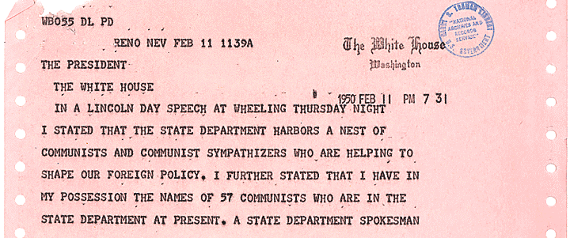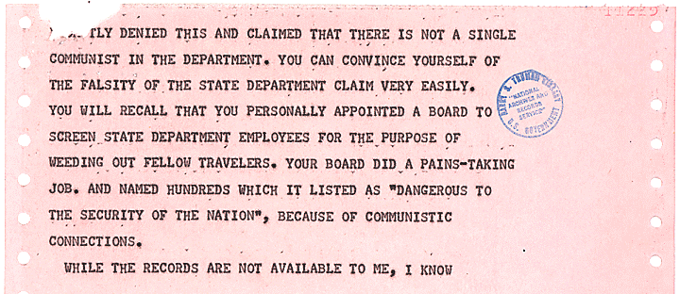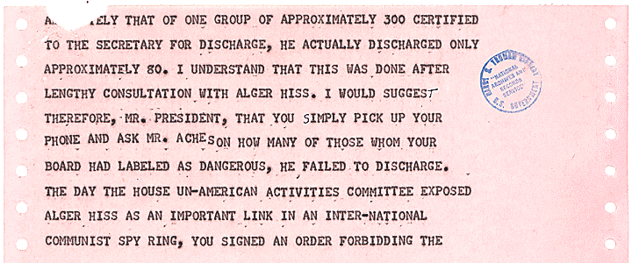
Notes from page 1 of the telegram

Notes from page 2 of the telegram

Notes from page 3 of the telegram

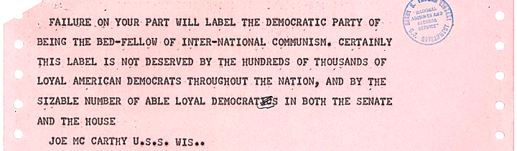
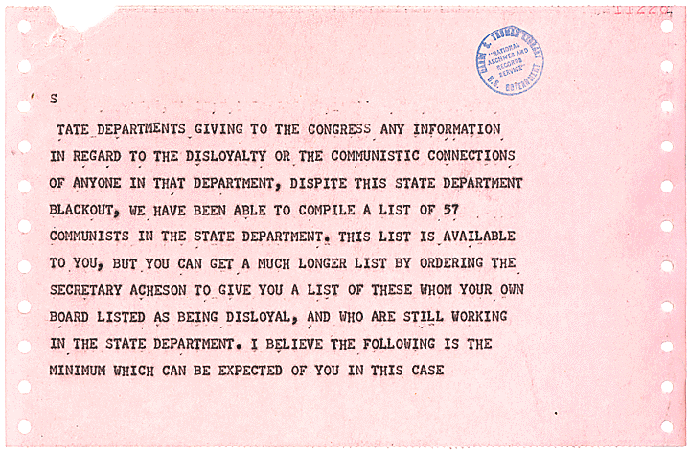
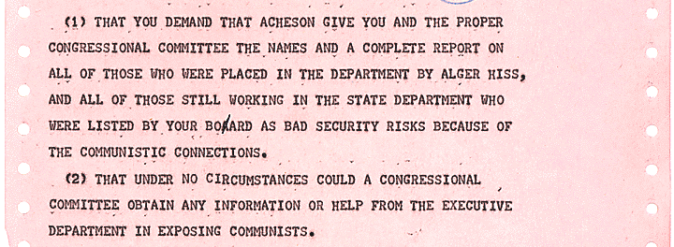
Notes from page 4 of the telegram

Notes from page 5 of the telegram

Notes from page 6 of the telegram

McCarthy Telegram Questions:
- What accusations does Senator Joseph McCarthy make in this telegram to President Truman? What do you think motivated McCarthy to send this telegram?

- How do you think the American people reacted when McCarthy made these accusations public in 1950?

- Assume the role of President Harry Truman. How would you respond to this telegram?

President Truman’s Response to the McCarthy Telegram, 1950
(The letter below was probably never sent)

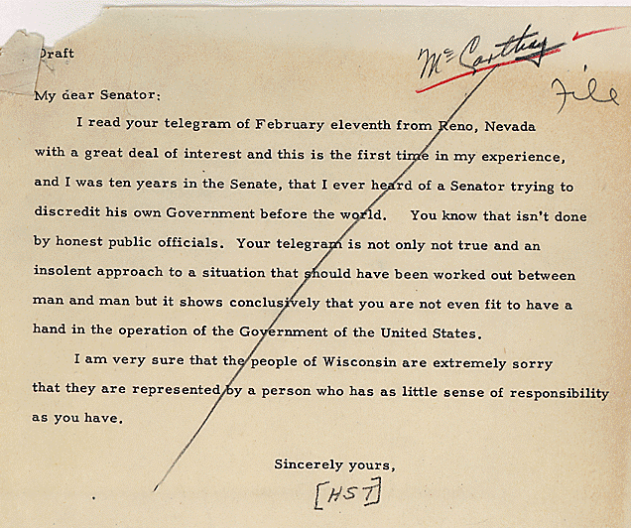

Truman Response Questions:
- How does President Truman respond to McCarthy’s accusations? What is the tone of this letter?

- Which side of this disagreement do you think most Americans would have chosen: McCarthy or Truman? Why?

- Examine the next document. What do all three of these documents reveal about American attitudes during the Cold War?



